梦亭
Bale Bengong
为华乐团而作
for Chinese Orchestra

周俊安
Chew Jun An

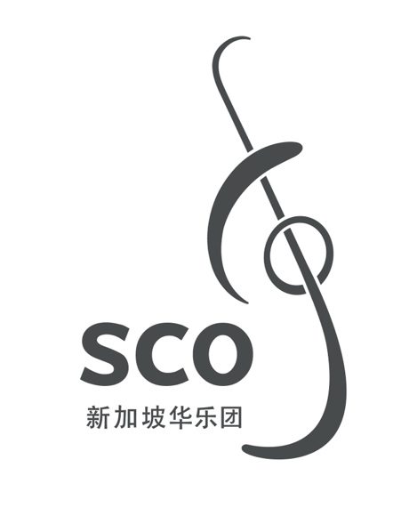

00/000
梦亭
Bale Bengong
为华乐团而作
for Chinese Orchestra

周俊安
Chew Jun An
(2015)
7'

梦 亭
Bale Bengong

ISMN

Copyright © Singapore Chinese Orchestra Co. Ltd. All rights reserved.

版权所有, 未经许可, 不得以任何形式印刷、复制、扫描或发行。
Unauthorised printing, reproduction, scanning or distribution is strictly prohibited
without the express permission of the copyright holder.

印刷于新加坡。
Printed in Singapore.

新加坡华乐团有限公司
珊顿道7号
新加坡大会堂
新加坡邮区 068810

Singapore Chinese Orchestra Co. Ltd.
7 Shenton Way
Singapore Conference Hall
Singapore 068810

网站Website: www.sco.com.sg
电邮Email: aa@sco.com.sg
电话Telephone: (65) 6557 4025
传真Fax: (65) 6557 275

传Biography
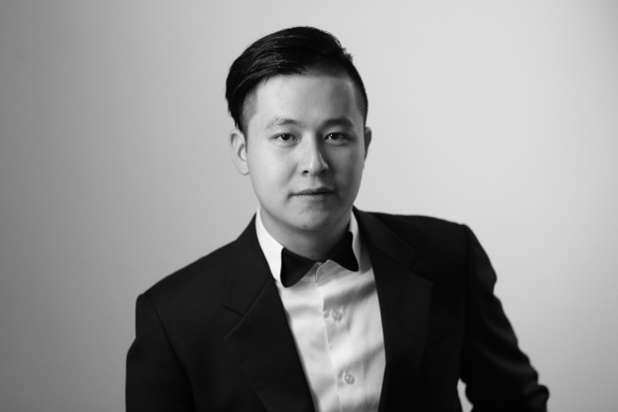
王东旭，作曲专业博士，中国音乐学院作曲系青年教师。先后毕业于中国音乐学院和中央音乐学院。
周俊安沉浸在多元文化中，力求将他吸收的音乐元素，独特的呈现在他风格丰富的作品中。他以扬琴演奏开始了他的音乐之旅，并开始创作音乐，致力于探索不同音乐风格之间的协调可能性。他从广泛的艺术兴趣中汲取音乐灵感，以体现他作品中元素的多样性。最近的首演作品有：在卡内基威尔音乐厅的钢琴独奏曲《雨天》，以及他与皮博迪歌剧院和制片人托尼阿诺德合作的第一场歌剧《狂人日记》。 2015年获新加坡国际华乐作曲大赛青年奖。2018 年，他的人声与电子乐作品《聆听森林》在 Prix d’Ete 比赛中获得二等奖，同年获得 Otto Ortmann曲奖。俊安的研究兴趣同样广泛且丰富，从Josquin 的香颂-经文歌、莫扎特的唐璜中的拉康女权主义，到南洋风的主题等。他目前的研究项目是使用荣格精神分析研发音乐分析范式。
俊安目前正在霍普金斯大学皮博迪音乐学院攻读音乐艺术博士学位，师从 Oscar Bettison，此前曾师从罗伟伦老师、Michael Hersch、Felipe Lara、Amy-Beth Kirsten 和 Jason Eckardt。现担任新加坡莱佛士音乐学院作曲学科主任和讲师。

Immersed in the cultural diversity, Chew Jun An seeks to seamlessly assimilate his experiences to present a unique voice in his eclectic body of works. He started his musical journey as a Chinese Dulcimer player and began writing music while exploring the synergistic possibilities between distinct musical styles through collaboration.
His music exemplifies his influences by drawing inspiration from his wide-ranging artistic interests. Recent premieres include his piano solo piece Hyetal Days at Weill Hall at Carnegie Hall as well as his first opera scene A Madman's Diary in collaboration with the Peabody Opera Department and producer Tony Arnold. In 2015, he won the Youth-Prize in the Singapore International Competition for Chinese Orchestra Composition. In 2018, his voice and electronics piece Hear the Forest Sing was accorded second prize in the Prix d'Ete Competition and later that year he was conferred the Otto Ortmann Award in Composition. Jun An's research interests are equally as eclectic and spans from Josquin's chanson-motets, Lacanian feminism in Mozart's Don Giovanni to topics on the Nanyang style. His current research project is in developing a music analytical paradigm using Jungian psychoanalysis. He is appointed Composition Subject Leader and Lecturer at the Singapore Raffles Music College.
Jun An is currently pursuing a Doctor of Musical Arts degree at the Peabody Conservatory under the tutelage of Oscar Bettison having previously studied with Law Wai Lun, Michael Hersch, Felipe Lara, Amy-Beth Kirsten and Jason Eckardt.

乐曲介绍Synopsis
Bale Bengong 是在印尼的巴厘岛上能常见的一种传统亭子。Bale Bengong翻译成“沉思屋”的意思。Bale Bengong周围宁静的环境让人迷失在自己发白日梦的想像中。各声部长音重叠给音乐铺垫如在沉思中的气氛，同时利用音量的变化升华出各种音质与和声。主题的扩张是利用换置基本旋律的重音, 自然生成和声与复调的原理创作的。从熟悉的题材创造新鲜的听觉经验。
此作品荣获2015年新加坡国际华乐作曲大赛新加坡青年作曲家奖。

A Bale Bengong is a traditional pavilion found on the island of Bali in Indonesian. The name "Bale Bengong", translated literally, would mean "thinking house" or "daydream house". A Bale Bengong is a place to carry out contemplative thinking or slip into a daydream amidst the stillness of the surroundings while being sheltered from the harsh Southeast Asian sun. The layering of voices in a seemingly endless drone creates a meditative atmosphere. Furthermore, the dynamic changes allow the different sonorities and timbres to expose and sublimate subtly from the orchestral timbre. The piece develops resultant sonorities and textures by layering linear motivic ideas. The interlacing colotomic structures unveil new intricacies in every listen.
This piece won the Young Singaporean Composer Award at the Singapore International Competition for Chinese Orchestral Composition 2015.

编制Instrumentation
梆笛 Bangdi
曲笛 Qudi I, II
新笛 Xindi I, II
高音笙 Gaoyin Sheng I, II
中音笙 Zhongyin Sheng
低音笙 Diyin Sheng
高音唢呐 Gaoyin Suona
中音唢呐 Zhongyin Suona I, II
高音管 Gaoyin Guan
低音管 Diyin Guan I, II
倍低音管 Beidiyin Guan

扬琴 Yangqin (2)*
柳琴 Liuqin
琵琶 Pipa
中阮 Zhongruan
大阮 Daruan
竖琴 Harp

定音鼓 Timpani
云锣 Yunluo
拍顫器 Vibraphone

高胡 Gaohu
二胡 Erhu
中胡 Zhonghu
大提琴 Violoncello
低音提琴 Contrabass

* 括号内的数字为推荐演奏人数。Numbers in parenthesis indicate recommended amount of players.

